IT LAB REPORT

- Archit Agrawal

**Objective 1**: Program to calculate sum of 5 subjects and find percentage

**Software**: Visual studio code

**Methodology:**

Here we take five subjects and take input from user their maximum marks and the marks obtained

Here we consider mm(maximum marks) , mo(marks obtained), totalMarks(sum of marks obtained), maximumMarks(sum of maximum marks), percentage( percentage obtained)

The idea is that we take maximumMarks and totalMarks for all subjects. Then we multiply sum of marks obtained by 100 and divide whole result by sum of maximum marks for all subject that is percentage = 100*totalMarks/maximumMarks

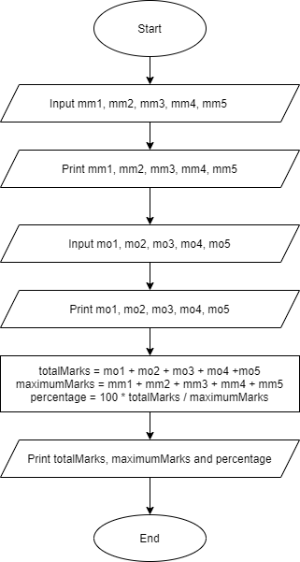**ALGORITHM FLOWCHART**

1. Start
2. Input mm1, mm2, mm3, mm4, mm5
3. Print mm1, mm2, mm3, mm4, mm5
4. Input mo1, mo2, mo3, mo4, mo5
5. Print mo1, mo2, mo3, mo4, mo5
6. totalMarks = mo1 + mo2 + mo3 + mo4 + mo5
7. maximumMarks = mm1 + mm2 + mm3 +

mm4 + mm5

1. percentage =

100 * totalMarks / maximumMarks

1. Print totalMarks, maximumMarks, percentage
2. End

**CODE:**

#include<stdio.h>

void main() {

    float mo1, mo2, mo3, mo4, mo5, totalMarks;

    float mm1, mm2, mm3, mm4, mm5, maximumMarks;

    float percentage;

    printf("Enter the maximum marks in 5 subjects. ");

    scanf("%f%f%f%f%f", &mm1, &mm2, &mm3, &mm4, &mm5);

    printf("Maximum marks in each subject are : %f, %f, %f, %f, %f\n", mm1, mm2, mm3, mm4, mm5);

    printf("Enter the marks obtained in each subject (in the same order as entered above) \n");

    scanf("%f%f%f%f%f", &mo1, &mo2, &mo3, &mo4, &mo5);

    printf("Marks obtained in each subject are : %f, %f, %f, %f, %f\n", mo1, mo2, mo3, mo4, mo5);

    maximumMarks = mm1 + mm2 + mm3 + mm4 + mm5;

    totalMarks = mo1 + mo2 + mo3 + mo4 + mo5 ;

    percentage = (totalMarks/ maximumMarks) * 100.0 ;

    printf("Total marks = %f\n", totalMarks);

    printf("Maximum Marks = %f\n", maximumMarks);

    printf("Percentage = %f", percentage);

}

**RESULT:**

Let maximum marks for each subject be 100.

Therefore, mm1 = mm2 = mm3 = mm4 =mm5 = 100

And let marks obtained in each subject be

Mo1 = 92 , mo2 = 96, mo3 = 95, mo4 = 95, mo5 = 87;

Therefore maximumMarks = 500 and totalMarks = 465

Therefore percentage = (465.0/500.0)*100 = 93.00

**OUTPUT:**

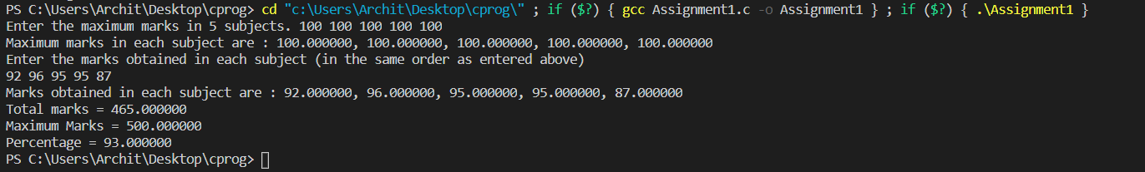

**Objective**: Program to show swap of two numbers without using a third variable.

**Software**: Visual studio code

**Methodology**: in this program we take two numbers ‘a’ and ‘b’. now we have two swap these numbers. Now the method is we are going to save value of ‘a’ in another variable using ‘a’ and ‘b’. the steps are as follows and let a =10 , b=20

1. a = a + b; //a=30 (10+20)

2. b = a - b; //b=10 (30-20)

3. a = a - b; //a=20 (30-10)

hence the above concept is to swap two number without using third variable.

**ALGORITHM FLOWCHART**

1. 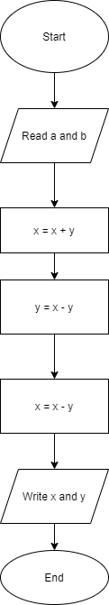Start
2. Input two numbers x and y
3. Print x and y
4. Compute x = x + y
5. Compute y = x – y
6. Compute x = x – y
7. Write x and y
8. End